Application Form
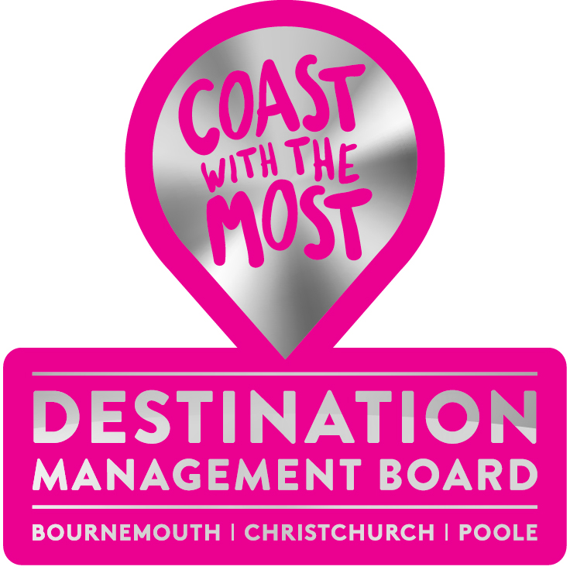
Vice Chair
Destination Management Board
(Bournemouth, Christchurch & Poole)

Applicants do not have to come from within the current Board but must have relevant experience.

Please complete and return to stephanie.sainsbury@bcpcouncl.gov.uk by no later than midnight on Sunday, 6 March 2022

Name:

Company/Business

Email address:

Mobile number:

Reason for wanting to take up this Board position & vision for the Board (in no more than 500 words).

Signed: Date:

